1. Study the given pedigree chart and choose the correct answer

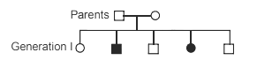

1. The trait understudy is dominant
2. Both parents are homozoygous
3. The trait can be X-linked recessive haemophilia
4. The trait understudy is autosomal recessive like cystic fibrosis
5. The trait studied in the pedigree below is:

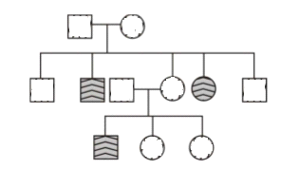

1. Autosomal recessive
2. Autosomal dominant
3. X-linked recessive
4. X linked dominant
5. The trait studied in this pedigree is X-linked recessive. Find the risk of couple 6 and 7 to have an affected child

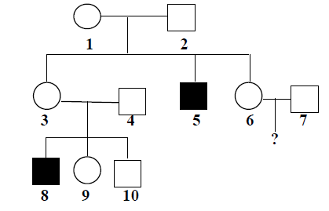

1. The risk of female affected is null
2. The risk of a boy affected is ½
3. The probability of the mother to carry Xd is 1/2
4. Only ‘a’ and ‘b’
5. All of the above
6. The pedigree below represents the inheritance of a recessive autosomal disease. Find the risk of child 15 to be affected

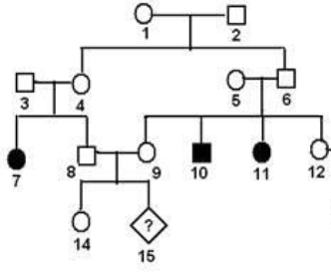

1. The probability of the mother to be heterozygote is ½
2. The risk is null since both parents are normal
3. The risk of affected child is 2/3 × 2/3 × ½ × ½
4. The risk of affected child is ¼
5. Phenylketonuria is a recessive autosomal disease that affects 1/10,000 of newborns world wide. This disease is related to a deficiency in an enzyme called PAH. A study performed on 1,200 children selected from an isolated community, showed that 30 children were heterozygous for PAH.

Calculate the proportion of heterozygous children in this community

1. 30/10,000
2. 1200/10,000
3. 30/1200
4. 1/30
5. The document below shows the nucleotide sequence of a fragment of the non- transcribed strand of the normal allele (**A1**) and the allele of the disease (**A2**) of the PHEX gene. The mutation observed in allele A2 is

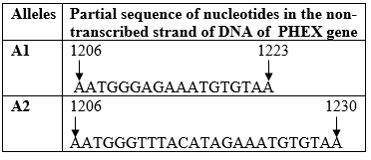

1. Point mutation by substitution
2. Point mutation by insertion
3. Frame-shift mutation by insertion
4. Frame-shift mutation by addition
5. The document below shows the transmission of Familial hypophosphatemia in a family. The disease is X-Linked dominant. Indicate the genotypes of individuals 13 and 14

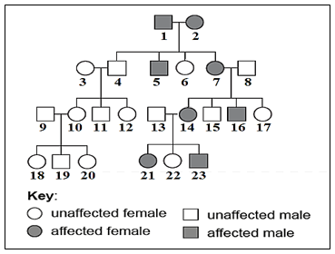

1. 13: XnY 14: XDXD
2. 13 XnY 14 XDXn
3. 13: XnY 14: XDXD or XDXn
4. 13 nn 14: Dn
5. The document below shows the transmission of Familial hypophosphatemia in a family. The disease is X-Linked dominant. The risk of individuals 13 and 14 to have affected child is



1. Null for females, null boys
2. Half of the females, null boys
3. Null of the boys, all females are affected
4. Half of the boys, all females are affected
5. Half of the females, half of boys are affected
6. The document below shows the transmission of Familial hypophosphatemia in a family. The disease is X-Linked dominant. Formulate a hypothesis explaining why female 6 is not affected



1. Female 6 doesn’t belong to the family
2. Female 6 has the diseased masked
3. Female 6 has turner syndrome, she possesses only 1 X chromosome carrying normal allele
4. Female 6 is a girl, and girls are not affected.